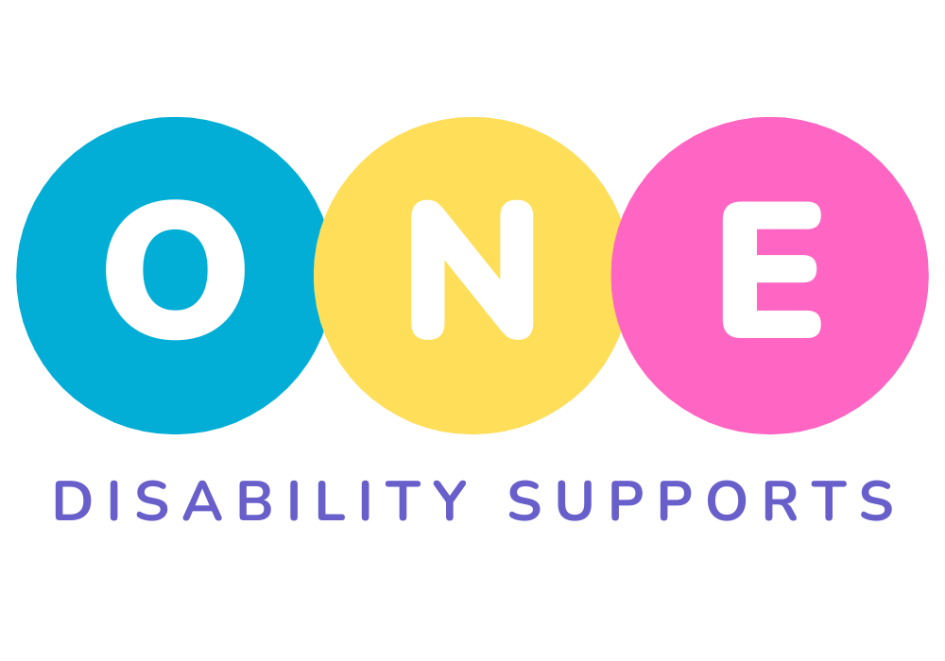
One Disability Supports

Complaints & Feedback Form
(Aligned with NDIS Code of Conduct & NDIS Complaints Management and Resolution Rules 2018)

1. Participant Details
Full Name: _________________________________________
NDIS Number (optional): ___________________________
Date of Birth: _______________________________________
Phone: ____________________________________________
Email: _____________________________________________
Address: ___________________________________________
Who is the complaint about?
(please specify): ______________________________________

2. Who Is Making the Complaint?
☐ Participant
☐ Family Member / Nominee
☐ Support Coordinator
☐ Advocate
☐ Staff Member
☐ Other: _____________________________________________
Your Name (if different from participant): ___________________________________
Relationship to Participant: ________________________________________________

3. Type of Feedback
☐ Complaint
☐ Concern
☐ Suggestion
☐ Positive Feedback

4. What is the Complaint / Feedback About?
(Please tick all that apply)
☐ Quality of support
☐ Safety concerns
☐ Staff behaviour or conduct
☐ Communication
☐ Respect & dignity
☐ Cultural needs
☐ Privacy or confidentiality
☐ Billing or charges
☐ Incident or event
☐ Other: _________________________________________

5. Details of the Complaint or Feedback
(Please describe what happened, including dates, names, and any key details)

6. What Outcome Would You Like?
(How would you like us to resolve this? What would help?)

7. Supporting Evidence (optional)
☐ Photos attached
☐ Documents attached
☐ Screenshots attached
☐ Other evidence: ____________________________________

8. Privacy & Consent
Would you like your complaint to be anonymous?
☐ Yes
☐ No
Can we contact you to discuss this complaint?
☐ Yes
☐ No
Preferred contact method:
☐ Phone ☐ Email ☐ SMS ☐ Other: ________________________

9. Acknowledgement
I understand this complaint will be handled respectfully, confidentially, and in accordance with the:
- NDIS Code of Conduct
- NDIS Complaints Management and Resolution Rules 2018
- One Disability Supports Internal Complaints Policy
Name: _________________________________________
Signature: ______________________________________
Date: ___________________________________________

If you wish to discuss this complaint further, please email: Admin@OneDisabilitySupports.com.au

We will promptly get back to you within 24 hours.

10. Office Use Only (Staff to Complete)
Date Received: ______________________
Received By: _________________________
Complaint Category: __________________
Risk Level: Low / Medium / High
Action Taken:

Outcome Provided to Participant:
☐ In writing ☐ Verbally ☐ Email
Date Outcome Provided: __________________
Investigation Completed By: _________________________
Notes:

NDIS External Complaint Options (Required by Law)
Participants may contact:

NDIS Quality and Safeguards Commission
Phone: 1800 035 544
NDIS website: ndiscommission.gov.au
Complaints can be made anonymously.

